Personal Information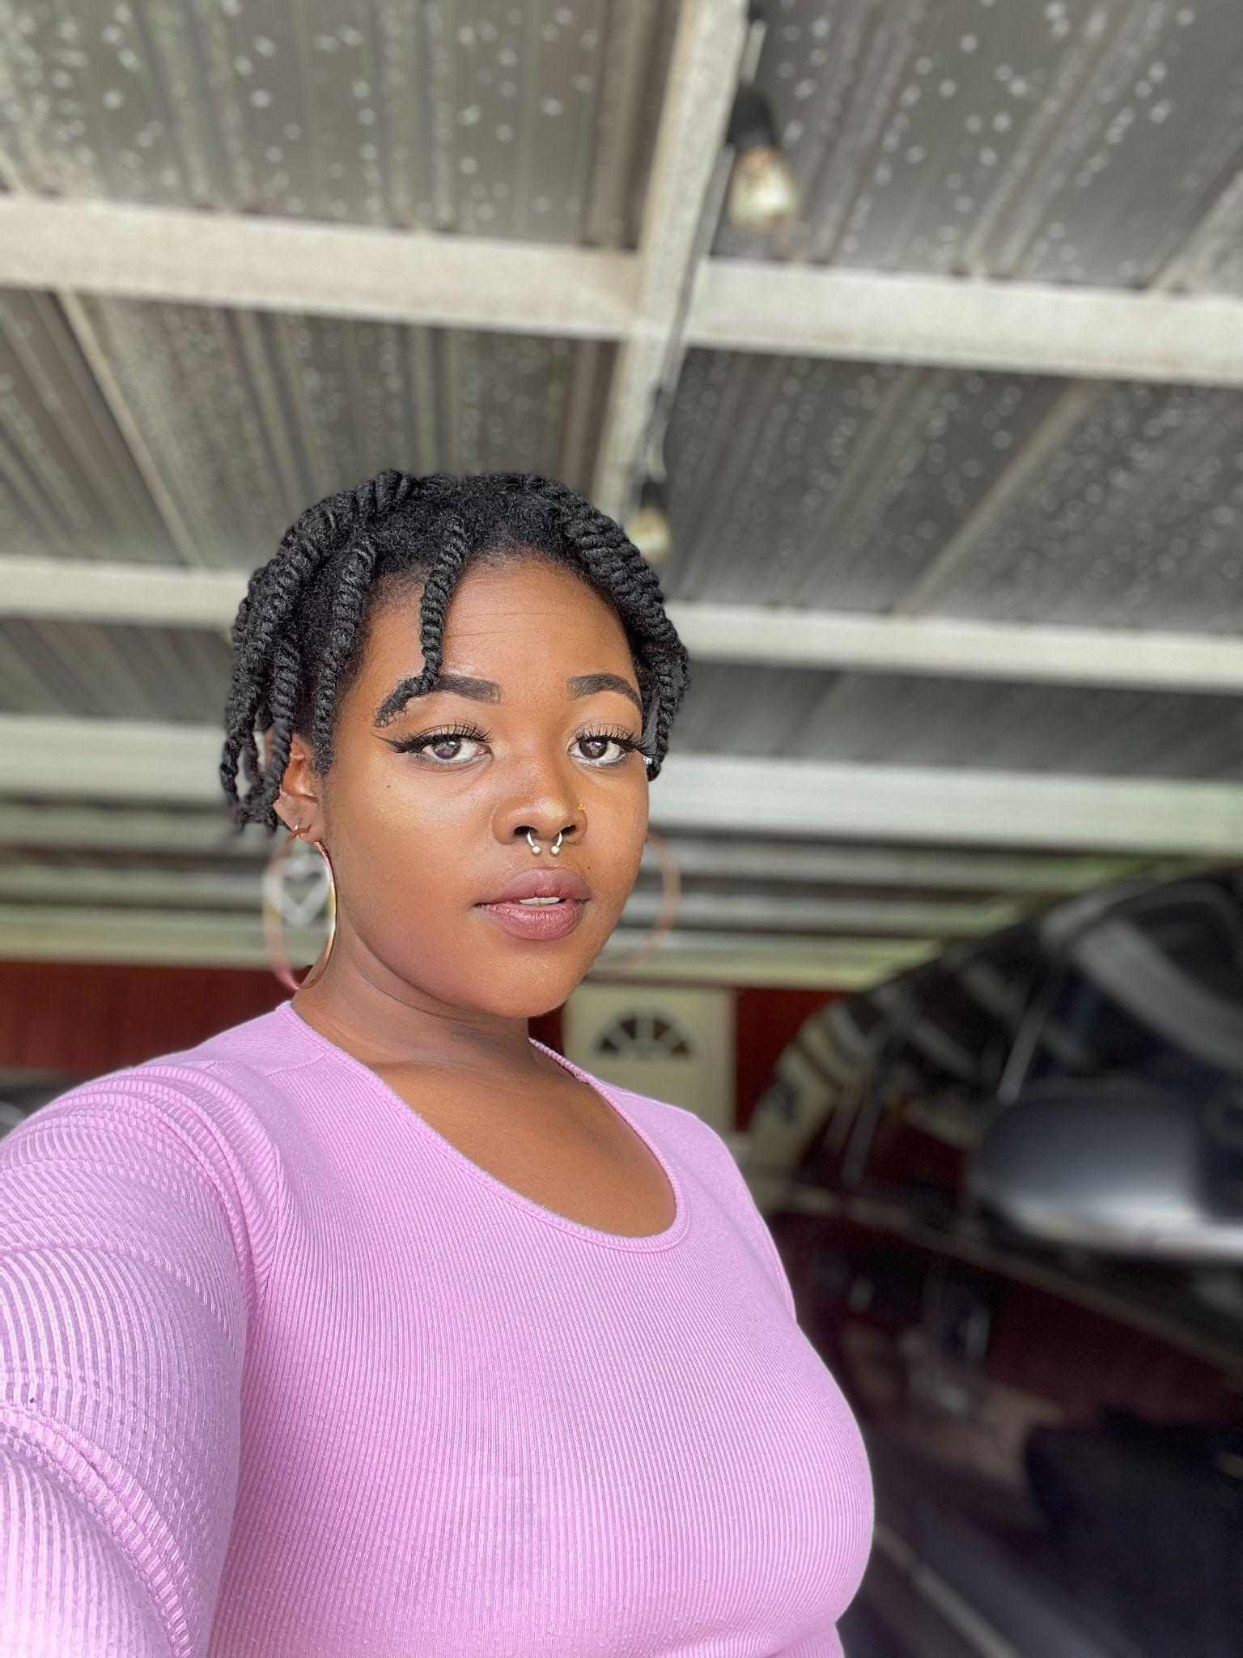

832-892-0214

Yesha.Bun@gmail.com

www.yeshabunch.com

Height: 5’ 3” (160 cm)

Weight: 170 lbs (77kg)

Eye Color: Brown

Hair Color: Dark Brown/ Black

____________________________________________________________________________________

**THEATER**

*Eurydice* Loud Stone San Jacinto College

Black Box Theatre ‘23

*Evolve* Ballet San Jacinto College Proscenium Theatre ‘22

*How to Succeed: In Business* Supporting Sam Rayburn Theatre ‘16

____________________________________________________________________________________

**EDUCATION & TRAINING**

San Jacinto College: Central | Acting I | Jerry Ivins​

San Jacinto College: South | Ballet I | Jaime Williams​

San Jacinto College: South | Acting II | Jonelle Walker

____________________________________________________________________________________

**SPECIAL SKILLS**

**Proficient Instruments**: Clarinet, Bass Clarinet, and Cello.

**Dance**: Classical Ballet and Color Guard ( 6 ft flags, Swing Flags, Chain Flags, rifle, saber). Vocal **Dialect**: British. **Makeup Artist**, **Gel X nail Technician/Artist**, and **Hair Stylist** ( Loctician, Cut/clip, Bleach and Dye, Braids/Twist).

**Mixed Media Artist**: Paint (oil, acrylic, Water color), Digital (Autodesk Sketchbook, Adobe illustrator), Traditional (Pen and Paper), Clay Sculpting, Sewing (needle and thread), Crochet. **Amature Cook.**

Commercial Resume available on request.